Making the Shade
Program Application

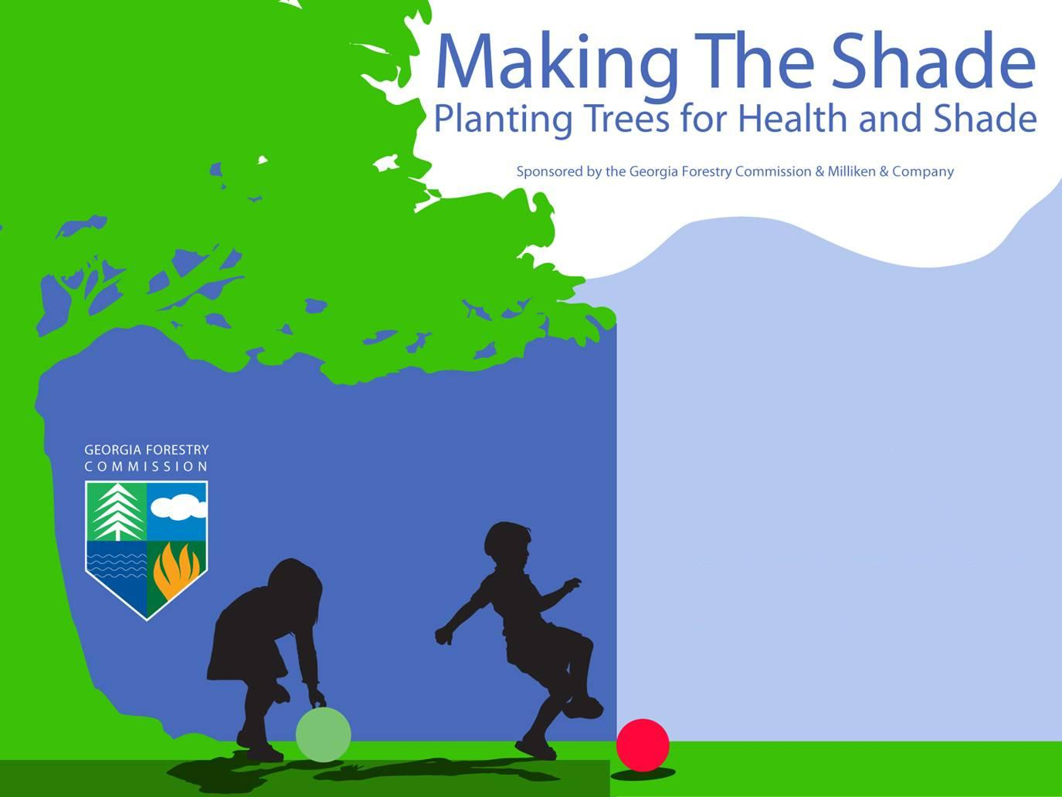

Making the Shade Program
Administered by the
Georgia Forestry Commission

Introduction
Making the Shade, a Georgia Forestry Commission (GFC) program in cooperation with the U.S. Forest Service, is designed to create healthier, shaded playground areas on elementary school campuses throughout Georgia. The GFC created Making the Shade to address children’s health issues that can be improved through the proper placement and planting of large-growing shade trees. In addition, such trees also provide multiple environmental, social and economic benefits while creating a better learning environment.
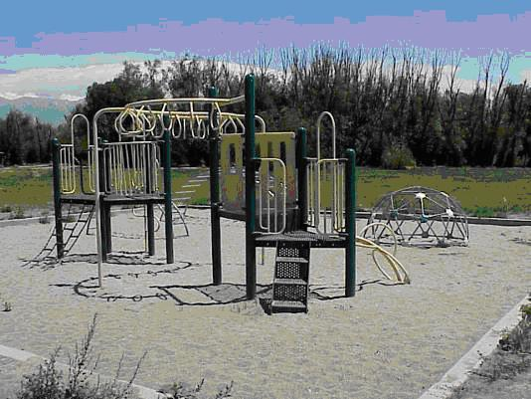
Playgrounds that are fully exposed to the sun are common in schoolyards across Georgia. Such playgrounds can become unhealthy places for children to play. Elevated surface temperatures on playground equipment can cause severe and painful burns. On some equipment, surface temperatures can easily reach anywhere from 120-140°F, which can burn a child’s skin in only three seconds.

In addition, only 15 minutes are needed for some children to become overexposed to the sun’s ultraviolet radiation. The cumulative effects of this overexposure can lead to skin damage and ultimately to some forms of skin cancer.

Another issue is ground level ozone which is at its peak around midday when children are often outside for recess. Ozone is a major cause of poor air-quality especially during periods of elevated temperatures. Since children inhale more pollution per pound of body weight than adults, and since lung-related problems such as asthma are often triggered by poor air quality, re-establishing shade on playgrounds can help reduce respiratory-related illnesses.

The Program Objectives of Making the Shade are:
- A reduction in surface temperatures of school yards and playground equipment
- A reduction in children’s skin damage
- A reduction in respiratory problems caused by elevated temperatures
- A reduction in air temperatures around playgrounds
- An increase in green learning environments and incorporation of the environmental benefits of trees into school curriculum
- An increase in energy conservation through shading of air conditioning equipment and school buildings

Program Overview

Eligible Recipients
Educational institutions, parent-teacher organizations, community tree volunteer groups and neighborhood associations are eligible for funding. A working relationship with a local GFC Forester must be established prior to application and be maintained during all project phases. Partnerships with school officials, the parent-teacher organization, local tree board/ nonprofit, a volunteer landscape architect, a local nursery and/or a corporate sponsor are strongly encouraged. Applicants must, at the time of grant award, be able to demonstrate that it can contribute the required cash and/or in-kind match.

Available Funds
Making the Shade Grant Program funds, which are provided through the Urban and Community Forestry grant program, will be awarded on a competitive basis. The maximum amount of the award is $5,000. Funding is for projects or activities not otherwise currently funded, and cannot be used to substitute for existing funds. Funding is not available for entertainment, food and beverages, computers, or purchase of equipment. The Georgia Forestry Commission reserves the right to reject any and all proposals or to approve partial funding for any and all proposals.

Match Requirements
Making the Shade Grant Program funds must be matched equally (dollar for dollar) with non-federal funds. These non-federal funds cannot be used as a match for any other Federal cost-share project. The match may include in-kind contributions, volunteer assistance, and private and public (non-Federal) monetary contributions. All matching funds must be specifically related to the proposed project.

In-kind contributions include on-hand supplies, third party donations of supplies or equipment, the value of time (including fringe benefits), professional services at the professional rate, or time spent by employees or volunteers on eligible project activities. Volunteer hours may be applied to the project at rates appropriate to the skill level of the volunteer and/or the nature of the work being performed. To determine the average value of adult volunteer labor, refer to the dollar amount specified by the Independent Sector by visiting their website. For children, use minimum wage as a standard.
www.independentsector.org/programs/research/volunteer_time.html.

Assistance provided by Federal employees or Georgia Forestry Commission staff may not be claimed as part of the match.

Cash purchases are direct, out-of-pocket expenditures for eligible project activities. If grant funds are awarded, please be prepared to document your match by providing copies of invoices, cancelled checks, signed receipts, payroll records, volunteer sign-in sheets, utility bills, etc.

Funds expended prior to the date of the grant agreement cannot be used as match. Funds expended for entertainment, food and beverages, computers, or purchase of equipment can not be used as match. Documentation of all matching funds must be provided before reimbursement of the grant award will be issued.

Grant Timeframe
Approved projects can begin only after a grant agreement is signed by the grantee and the State Forester. The recipient has one year to complete the project.

Final Report
A final report is required of the grantee at completion of the project.

Payment Process
Payments will be made upon project completion and review of the Final Report, or according to a payment schedule agreed to in advance. The Georgia Forestry Commission reserves the right to make partial payments subject to completion of scheduled milestones.

Eligible Projects
Eligible Projects must meet program objectives. The Making the Shade program is intended to support new initiatives, programs, projects or activities not currently being funded through other sources. Making the Shade is not intended for the purpose of beautification tree plantings.

Ineligible Projects
Ineligible projects include, but are not limited to; trail design and maintenance, property acquisition and related costs, beautification projects, tree removal and maintenance.

General Requirements
A copy of the completed application must be submitted to the Community Forester and also by e-mail or mail to:
jscales@gfc.state.ga.us
or
Making the Shade Program
Georgia Forestry Commission
1055 East Whitehall Road
Athens, GA 30605

A signed liability waiver and endorsement letter (form at the end of the application) must be submitted with each application.

Applicants must sign a grant agreement with the state forester before the project can begin.

Questions: Contact Joan Scales, jscales@gfc.state.ga.us or 478-733-2604.

Application Form
Making the Shade Grant Program
Please type
This page must be the first page of your application packet.
(For office use only)
Grant #:__________
GFC District # __________
SCFP District ___________

Project Information
Project Title  (10 words or less): | Making the Shade at
Applicant Information
Organization Name:
FEI Number: |  |  |  |  |  | 501(c)3 status: YES NO
Project Manager (All correspondence will be directed to this contact.):
First Name: |  |  |  | Last Name:
Title:
Mailing Address:
City: |  |  | County: |  |  |  | State: |  | Zip:
Phone (school year): |  |  | Phone (summer break):
E-Mail Address (school year):
E-Mail Address (summer break):
Financial Information
Grant Funds Requested + Total Cash Match + Total In-Kind Match = Total Amount of Project
Grant Funds Requested |  | $
Total Cash Match |  | $
Total In-Kind Match |  | $
Total Amount of Project |  | $
Signature of Agreement
As the duly authorized representative of the applicant named above, I hereby certify that all parts of this grant application have been read and understood and that all information submitted herein is true and correct. If awarded a grant under the Urban and Community Forestry Grant Program of the Georgia Forestry Commission, said organization agrees to comply with all Federal and State guidelines for completion of the grant.
________________________________________________________ ______________________
Signature of Authorized Representative Date

________________________________________________________________________________
Name and Title of Authorized Representative (Please print or type)

Proposal Narrative

Please type into the outline below and provide concise responses to the questions.

I. Purpose and Objectives
To plant # trees on the ____________________school campus for the following objectives:

Reduce surface temperatures of playground equipment

Reduce ultraviolet radiation exposure

Decrease ground level ozone

Foster an educational, healthy and fun environment
- Improve air quality
- Improve energy conservation
- Develop school curriculum reinforcing the environmental benefits of tree
- Provide a green learning environment

II. Project Detail

- Describe the activities that will occur to complete the project and indicate who will be responsible for each activity:

- Provide tentative dates for the completion of each activity:

- Describe how the trees will be watered and maintained for three years and the organization responsible for the maintenance:

- Describe how information about the Making the Shade project will be incorporated into classroom activities/school curriculum:

- Will the project be publicized to the student body, parents, community, legislators or the media? If so, how?

III. Budget

- Please list the items or activities that will be financed by the grant funds. Include the tentative dollar amount of funding used for each item:

- Please indicate how the match requirement will be met (refer to the match section in the guidelines). Include the tentative dollar amount of each item and the source of the match:

- Please complete and submit the budget table below:

Financial Detail Form
Application for Federal Assistance

U&CF Sub-Grant Funds From The

Georgia Forestry Commission

Project Title: | Making the Shade at

Cost Category | Grant Funds Requested | Cash Match | In-Kind Match | Total
Value of Staff or Volunteer Time
(applies to In-Kind match only)
Plant Materials
Watering Supplies

Landscape services or Equipment rental
Other: (Please Specify)

Totals | $ | $ | $ | $

Liability Waiver
Letter of Endorsement

________________________________________________________ hereby releases the
(Organization name)

Georgia Forestry Commission from any liability associated with contractors, volunteers, local

government employees or other persons working on the Making the Shade Grant Project.

Permission and access to school grounds has been granted to plant trees at

_______________________________________________________________.
(School/Location)

Printed Name of Authorized Representative: | _____________________________________________________________
Signature: | _____________________________________________________________
Title: | _____________________________________________________________
Date: | _____________________________________________________________

